**DIGITAL IMAGE PROCESSING**

**REPORT**

**Topic : Facial detection in a live video using Viola Jones algorithm .**

**From,**

**TEJAS.K**

**Digital Image Processing**

**Report**

**Project name: Face Detection in a live video using Viola Jones method, crop that face from live video for further recognition purpose.**

Theory :

Viola Jones is a famous algorithm , which is used to detect a non-tilted face in a still photograph. Here in this following project we shall see how to detect a face from Viola Jones algorithm , in live video capturing from laptop integrated webcam and to crop that face for further detection purpose.

**Software’s required** : Matlab 2014 version and above

Additional support package in Matlab called “USB WEBCAMS”.

In each snapshot apply Viola Jones algorithm to detect face

Take a series of snapshots to make a video from it.

Initialize webcam()

Install the required software’s and add-ons in MATLAB.

→

→

→

↓

Use this cropped image for further storing/identifiying/ recognition purposes.

←

Whenever a face is detected, crop face and store.

Figure : Flowchart illustrating different steps in the above experiment.

**Explanation :**

**V**iola Jones algorithm employs an inbuilt library function called “cascadeobjectdetector()” which is a face detecting object used by Matlab.

This function employs the following 4 processes to detect a non-tilted face in a given still photograph.

INTEGRAL IMAGING

CASCADING

ADA-BOOSTING

HAAR ALGORITHM

FIG: Block diagram representing Viola Jones algorithm.

* HAAR ALGORITHM :

Object Detection using Haar feature-based cascade classifiers is an effective object detection method proposed by Paul Viola and Michael Jones.

Each feature is a single value obtained by subtracting sum of pixels under white rectangle from sum of pixels under black rectangle.

Various features of face , like for example the intensity near eyes is less than forehead and cheeks , nose region is brighter than the cheeks etc etc are loaded.

A rectangle of optimum size will be applied onevery part of the photograph. While applying the rectangle the features loaded are checked by using rectangles of 4 different sizes. The best matching feature wil be recognized as face.

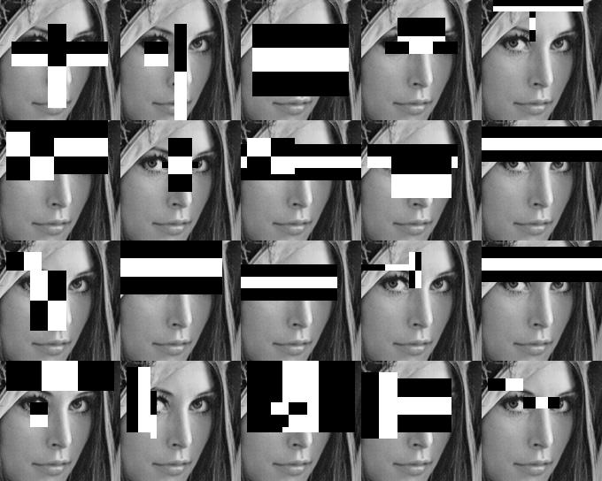

* INTEGRAL IMAGING :

Here instead of counting each pixel while calculating pixels, it sums the pixels to the left and top of it to produce the integral pixel, which saves the execution time.

* ADABOOSTING :

When the rectangles are applied , from the first few results it decides wether it is a face or not, if not it jumps to the next part of the pic, instead of wasting time calculating unwanted pixel results.

* CASCADING:

The classifiers are arranged in a series manner in which the photograph undergoes the process, this further decreases the time of execution.

MATLAB COMMANDS :

On using the command “webcam()” the integrated laptop webcam will be initiated. “Snapshot(webcam)” takes a pic, “imshow” displays the picture,

Now in this project function “image” is used instead of “imshow” inorder to show a sequence of consecutive snapshots taken , which forms a video.

This whole functions runs in a while(1) loop i.e a loop which never terminates.

The optimum size of the rectangle applied on the face to detect the face is termed as bounding box. According to the size of this box the face is then cropped using the command “imcrop” for further use of identification or recognition of the face.

**MATLAB CODE :**

clear all

clc

FDetect = vision.CascadeObjectDetector();

detector.MergeThreshold=100;

cam=webcam();

while(1)

I=snapshot(cam);

BB = step(FDetect,I);

size(BB,1);

image(I); hold on

for i = 1:size(BB,1)

rectangle('Position',BB(i,:),'LineWidth',5,'LineStyle','-','EdgeColor','r');

end

title('Face Detection');

hold off;

for i=1:size(BB,1)

I2=imcrop(I,BB(i,:));

figure()

imshow(I2);

end

end

**Conclusion:**

In this way a continuous video is formed, and when ever a face is detected in the video, the face is cropped and saved for further recognition purpose. Multiple faces in a single frame are also successfully recognized and cropped.

This can be used in various places like :

* Taking attendance in classrooms. One photograph of all students sitting in the classroom is enough to take their attendance, since it crops each face, identifies and marks present.
* Security purpose, one such camera near your door can have a record of all faces cropped who enters the house/company/public place/cars.
* If a database of criminals is loaded to this program, and if such cameras are allotted in the public railway stations/bus stand/traffic places etc, once a face in the data base is found, it will intimate that to the police immediately. This can also be done to find the missing people, especially children across the country.

RESULT :

SNAPSHOT FROM A LIVEVIDEO

